**MODULES:**  
Modules in Python are files containing Python code. They encapsulate reusable code. Accessed using ‘import’. Promotes code organization and reusability.

**Pre-defined modules:**

Built-in modules in Python. Provide additional functionalities. Examples include math, random and datetime. Accessed using import statement.

**User defined modules:**  
Custom modules created by users. Encapsulate reusable code. Defined in separate Python files. Imported using import for code organization.

**Example:**

Here we have a module calc.py, which has some functions, in which pre-defined module math is imported. Sqrt() is being used using math module.

Then, in the client.py and client2.py we have imported the functions of calc.py and shown code reusability.

**Module – Calc.py**

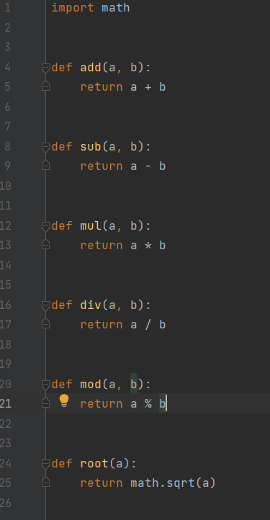

**Client1:**

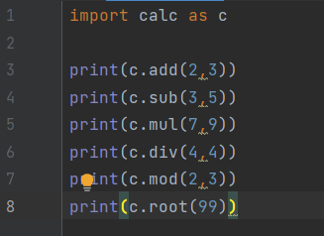

**Output:**

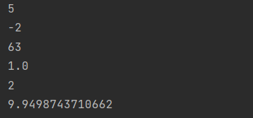

**Client2:**

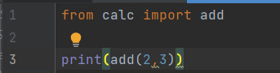

**Output:**

